**Standard Chartered Bank (Wholesale), Pasadena, CA Jan 2006 - Jan 2007**

***Sr. Business Consultant/Analyst***

**Client Brief**

Standard Chartered Bank offers a wide range of banking products and financial services to corporate and retail customers through a variety of delivery channels and through its specialized subsidiaries and affiliates in the areas of investment banking, life and non-life insurance, venture capital and asset management.

**Project: Straight2Bank (Wholesale Banking)**

The aim of the project was to enable corporates to choose amongst a suite of connectivity options to provide them with one-click access to their business information. These electronic options were embedded with comprehensive security features, flexible authorization matrix, and superior risk management and MIS capability to put them firmly in control of their business environment.

**Responsibilities**

* Involved in **Requirement Scoping** and analyzing high priority requirement for implementation.
* Investigated and analyzed system to track activities of customer accounts.
* Managed and delivered several major technology and operations projects in the **Wholesale Banking** using Standard Chartered’s standard **SDLC methodologies.**  Proactively **identified projects risks** and incorporated risk mitigating solutions and processes.
* Followed the **RUP methodology** right from inception to the projects transition.
* **Liaison** between stakeholders, system users, SME’s, software development team and the QA team throughout all phases in the RUP methodology.
* Facilitated (**JAD) Joint application Development** sessions to identify the potential problems and resolve them and then documented them in a format that can be reviewed and understood by both business people and technical people.
* Analyzed Requirements and created **Use cases, Use Case diagrams, Activity Diagrams using Rational Rose.**
* Helped QA Team in writing **test cases, test plans** and tested the final application for usability testing to verify whether all the user requirements were catered to by the application.
* Archived all project documents and implemented the UCM model for activity-based configuration management using Clear Case.
* Used **Rational Clear Quest for defect tracking** and change management request and reported them.
* Involved in preparing a simple and detailed User manual for the application, for an intended novice user.
* **Gathered user requirements** and **developed Use Cases/diagrams**, Conceptual Model, Behavior and **Class diagrams** using Rational Rose
* **Conducted project** related **presentations** and provided reports to the higher management.
* Interacted with the Helpdesk team to investigate and resolve production issues.

**Environment:**

Windows NT, IE and Oracle8.1, Rational Suite (Requisite Pro, Clear Case, and Clear Quest)

**ABOUT THE PROJECT**

##### I worked for a project called Straight2Bank which provided its wholesale customers a fully integrated end-to-end electronic platform that gave a single point of access for various transactions allowing them to streamline their workflow processes.

In particular, the service I was working on was **Straight2Bank FX Fixings Service**. It was an externally audited system which used proprietary algorithms that take into account… factors such as time and then calculate rates from contributing prices across the entire trading market.

My project was to create a platform where the customer could trade different currencies and on the basis of various business rules, different algorithms, different market prices, the rates were decided. This service also enabled the customers to buy and sell contracts online in different currencies for different periods of time.

Other than FX Fixings Service project, I also worked on Payroll Mgt system. Direct debits, Direct credit and Payment of utilities project.

I acted as a Liaison between stakeholders, Business users, SMEs, software development team and the QA team throughout all the phase of SDLC.

***Advice for Tanu***: Do not be constrained by what is in your project description in the resume. Assume that you had no project description on your resume! What would you have done then? Feel free to talk about anything!

**Question**: You mention that you provided “MIS capability to put them firmly in control of their business environment”! What do you mean?

**Answer:** Our project’s motive was to empower our customers with the best suite of applications (based on Information Technology, based on Information Systems) out there that helped them transact their business with utmost accuracy and least manual support from Standard Chartered!

**Question:** What do you mean by integrating flexible authorization matrix into your application?

**Answer:** What I mean by this is that I personally studied the various roles of individuals in our customer base. These roles were e.g., “FIN_ROLE”, “FOREX_ROLE”, “TRADING_ROLE”, “TANU TO ADD MORE ROLES”. Each of these roles were supposed to have some capabilities. I created an Excel spread-sheet that captured the roles in rows and the various capabilities in columns and then just put an X in the corresponding cell that indicates which role has which capability.

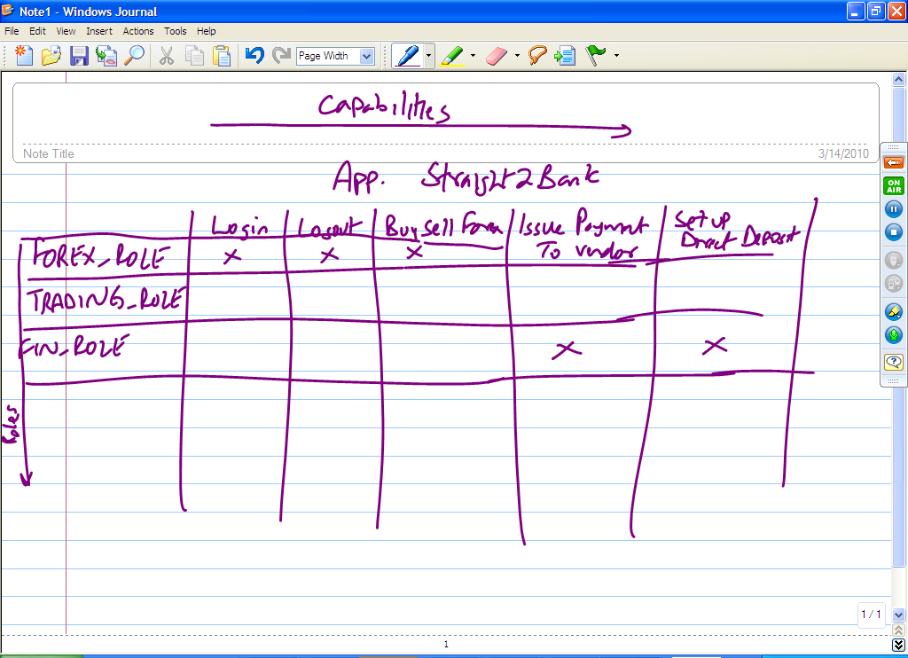

**But, Tanu: I differ! I don’t think you are done! Where are all the questions that my “Why Alok asks for Project write ups” has? But, now you will work on it, right!!!! YAY!!!! Thanks!!!**

Straight2Bank – for payments,

collections, trade finance

(open account and documentary),

foreign exchange, securities

services

Straight2Bank is an award winning

platform and has been recognised with 29

Global Finance World’s Best Internet Bank

award wins,

<http://www.identrust.com/pdf/Standard_Chartered_Bank_Case_Story.pdf>

**Where were you working?**

Pasadena, California  
790 E. Colorado Blvd., Suite 808  
Pasadena, California  91101  
Tel:               +1 212 667 0700         +1 212 667 0700  
Fax: +1 212 667 0380